Assignment 4 - Part 2 - (Assignment 5 part below ⬇️)

Advanced Join Queries (similar to Q9 & Q10)

Similar to Q9

SELECT BOOKINGID, STATUS, NUMGUESTS, TOTALPRICE, e.EMPNAME, b.EMPLOYEEID
FROM BOOKING b, EMPLOYEE e
WHERE b.EMPLOYEEID = e.EMPLOYEEID
ORDER BY e.EMPLOYEEID;

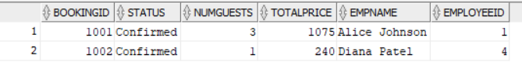

Similar to Q10

SELECT DISTINCT b.BOOKINGID, c.CUSNAME, b.TOTALPRICE
FROM BOOKING b, BOOKING_CUSTOMER bc, BOOKING_ROOM br, CUSTOMER c
WHERE b.BOOKINGID = bc.BOOKINGID
AND b.BOOKINGID = br.BOOKINGID
AND bc.CUSTOMERID = c.CUSTOMERID
ORDER BY b.BOOKINGID;

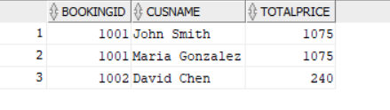

Views

#1 - VIEW_BOOKING_WITH_CUSTOMERS
This view shows all bookings that have customers.

It joins the Employee table with the Booking Table to show an employee’s name in the HandledBy column.

It also shows the list of all customers associated with this booking in the Customers column.
These customers are ordered by their name, so it is alphabetical ordering.

CREATE OR REPLACE VIEW VIEW_BOOKING_WITH_CUSTOMERS AS
SELECT
b.BookingID,
TO_CHAR(b.CheckIn, 'YYYY-MM-DD') AS CheckIn,
TO_CHAR(b.CheckOut, 'YYYY-MM-DD') AS CheckOut,
b.Status,
b.NumGuests,
b.TotalPrice,
e.EmpName AS HandledBy,
LISTAGG(c.CusName, ', ') WITHIN GROUP (ORDER BY c.CusName) AS Customers
FROM Booking b
JOIN Employee e
ON e.EmployeeID = b.EmployeeID
LEFT JOIN Booking_Customer bc
ON bc.BookingID = b.BookingID
LEFT JOIN Customer c
ON c.CustomerID = bc.CustomerID
GROUP BY
b.BookingID, b.CheckIn, b.CheckOut, b.Status, b.NumGuests, b.TotalPrice, e.EmpName;
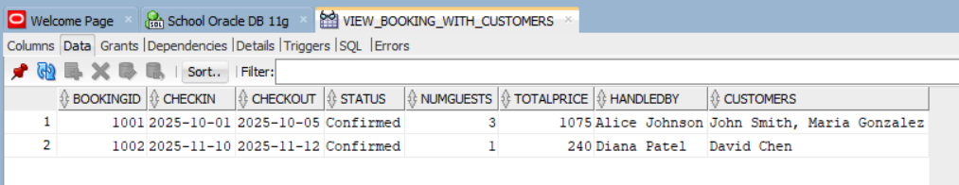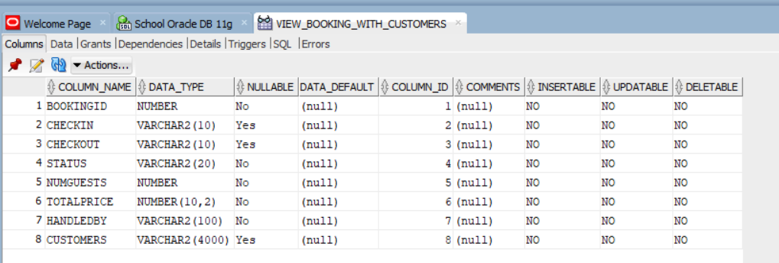

#2 - VIEW_ACTIVE_CUSTOMERS
This view shows all active customers. Meaning customers that have a booking associated with them.

It joins the Customer table with the Booking_Customer table.

It also uses the DISTINCT keyword, so that if a customer is associated with more than one booking, they will NOT show multiple times in different rows. Rather, they will just show up once.

CREATE OR REPLACE VIEW VIEW_ACTIVE_CUSTOMERS AS
SELECT DISTINCT
c.CustomerID,
c.CusName,
c.Email
FROM Customer c
JOIN Booking_Customer bc
ON bc.CustomerID = c.CustomerID;

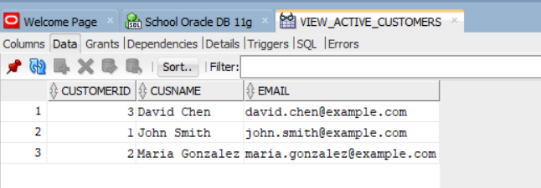
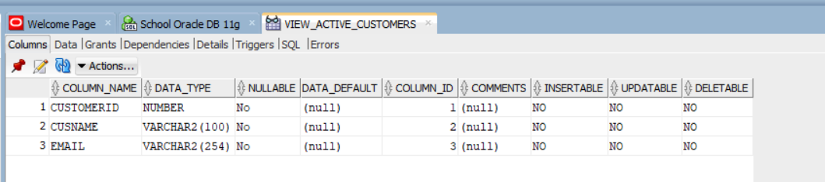

#3 - VIEW_BOOKING_SERVICES

This view shows which services add ons are associated with a booking, and which customers for which the service is for.

CREATE OR REPLACE VIEW VIEW_BOOKING_SERVICES AS
SELECT
b.BookingID,
TO_CHAR(b.CheckIn,'YYYY-MM-DD') AS CheckIn,
TO_CHAR(b.CheckOut, 'YYYY-MM-DD') AS CheckOut,
e.EmpName AS EmployeeName,
c.CusName AS CustomerName,
s.ServiceName,
sb.Quantity,
sb.TotalPrice
FROM Booking b
JOIN Employee e ON e.EmployeeID = b.EmployeeID
JOIN Booking_Customer bc ON bc.BookingID = b.BookingID
JOIN Customer c ON c.CustomerID = bc.CustomerID
JOIN Service_Booking sb ON sb.BookingID = b.BookingID
JOIN Service s ON s.ServiceID = sb.ServiceID;

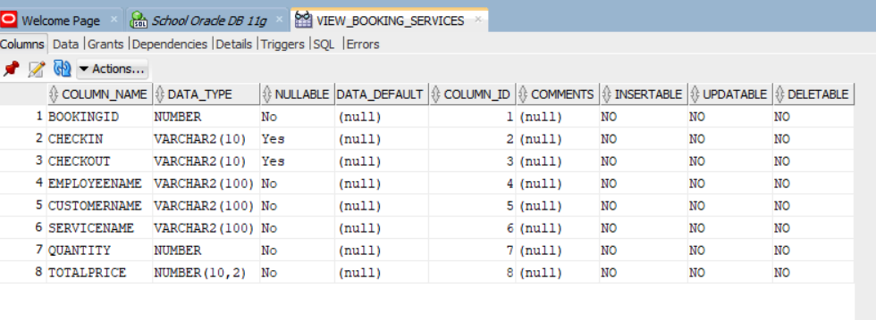
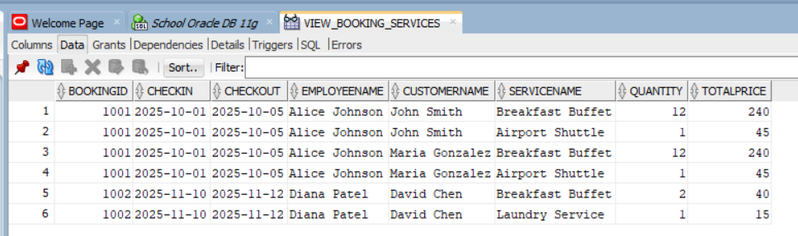

Assignment 5

Queries that are like Q11 - Q23

#1 - CUSTOMERs that have not made any BOOKINGs

SELECT C.CUSTOMERID, C.CUSNAME
FROM CUSTOMER C
WHERE
NOT EXISTS (
SELECT 1
FROM BOOKING_CUSTOMER BC
WHERE C.CUSTOMERID = BC.CUSTOMERID
);

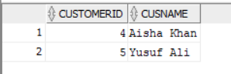

#2 - EMPLOYEEs that have no associated BOOKING OR BOOKINGSs with a TOTALPRICE < 300.

SELECT E.EMPLOYEEID, E.EMPNAME
FROM EMPLOYEE E
WHERE NOT EXISTS (
SELECT 1 FROM BOOKING B WHERE E.EMPLOYEEID = B.EMPLOYEEID
)
UNION
SELECT E.EMPLOYEEID, E.EMPNAME
FROM EMPLOYEE E
WHERE EXISTS (SELECT 1 FROM BOOKING B WHERE B.EMPLOYEEID = E.EMPLOYEEID)
AND EXISTS (SELECT 1 FROM BOOKING B WHERE B.EMPLOYEEID = E.EMPLOYEEID
AND B.TOTALPRICE < 300);

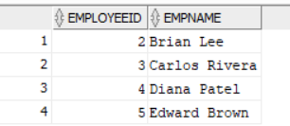

#3 - For each BOOKING, how many unique SERVICEs were used. Only count BOOKINGs whose # of SERVICEs is >= 2.

SELECT SB.BOOKINGID, COUNT(DISTINCT SB.SERVICEID) AS NUMSERVICES
FROM SERVICE_BOOKING SB
GROUP BY SB.BOOKINGID
HAVING COUNT(DISTINCT SB.ServiceID) >= 2
ORDER BY SB.BOOKINGID;

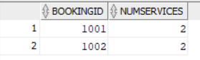

#4 - Calculate the total QUANTITY of a SERVICE across all BOOKINGs.

SELECT S.SERVICEID, S.SERVICENAME, SUM(SB.QUANTITY) AS TOTALQUANTITY
FROM SERVICE S , SERVICE_BOOKING SB
WHERE S.SERVICEID = SB.SERVICEID
GROUP BY S.SERVICEID, S.SERVICENAME
ORDER BY TOTALQUANTITY DESC;

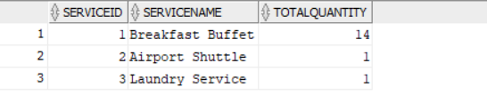

#5 - Find all EMPLOYEEs who are associated with a BOOKING, but exclude EMPLOYEEs who earn a SALARY of at least 50000.

SELECT E.EMPLOYEEID, E.EMPNAME
FROM EMPLOYEE E, BOOKING B
WHERE E.EMPLOYEEID = B.EMPLOYEEID
MINUS
SELECT E.EMPLOYEEID, E.EMPNAME
FROM EMPLOYEE E
WHERE E.SALARY >= 50000;

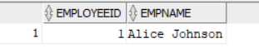

#6 - Show how many bookings are associated with a QROOMTYPE. Don’t show ROOMTYPES that have 0 bookings.

SELECT R.ROOMTYPE, COUNT(BR.BOOKINGID) AS NUMBOOKINGS
FROM ROOM R, BOOKING_ROOM BR
WHERE R.ROOMID = BR.ROOMID
GROUP BY R.ROOMTYPE
ORDER BY NUMBOOKINGS DESC;

